Contact Details
Title |  | First Name
Surname
Organisation
Job Title
Contact Phone Number
Contact E-Mail Address

Contact Address
Building / House Name |  | Number
Street Name
Town
County
Country |  | Postcode

Delivery Address (If Different From Above)
Building / House Name |  | Number
Street Name
Town
County
Country |  | Postcode

Item | Description |  |  | Price | Quantity Required
Workbook for Staff of Licensed Premises  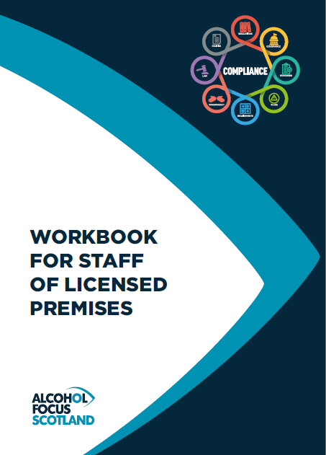 | An ideal tool for Personal Licence Holders to use to train staff under the Licensing (Scotland) Act 2005.  The Workbook covers the information required by law and includes details of other areas relevant to licensed premises.  “Alcohol Focus Scotland reserves the right to amend the workbook price “ |  |  | £7.99
Payment method: | Invoice? ☒ | Credit card Link? ☒ | Bank Transfer: ☒

Please email your completed form to: training@alcohol-focus-scotland.org.uk

Terms & Conditions
Payment for Your Materials
We will send you an order confirmation detailing your order and the overall cost, including postage.
Payment can be made using either:
- Invoice.
- Credit card payment link.
- Bank transfer.
Materials must be paid for before they will be dispatched.
Once payment has been received your order shall be dispatched on the nearest possible date, your receipt of payment shall be included with the order.
Data Protection
In compliance with the General Data Protection Regulation (GDPR), the information you have supplied will be stored securely in electronic form and will be used by Alcohol Focus Scotland to process your order and all related purposes. We will keep the information no longer than is necessary to do this.
Mailing List
We would also like to add you to our mailing list, to contact you occasionally with other information we think may be of interest to you, for example, new training materials or upcoming training opportunities.
If you consent to receive these mailings, you may opt out at a later date, by contacting us at training@alcohol-focus-scotland.org.uk
Please tick the box if you would like to receive this information. 

