Contact Details
Title |  | First Name
Surname
Organisation
Job Title
Contact Phone Number
Contact E-Mail Address

Contact Address
Building / House Name |  | Number
Street Name
Town
County
Country |  | Postcode

Delivery Address (If Different From Above)
Building / House Name |  | Number
Street Name
Town
County
Country |  | Postcode

Item | Description | Price | Quantity Required
Workbook for Staff of Licensed Premises  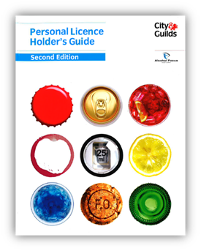 | An ideal tool for Personal Licence Holders to use to train staff under the Licensing (Scotland) Act 2005.  The Workbook covers the information required by law and includes details of other areas relevant to licensed premises. | £5.99
Personal Licence Holder’s Guide 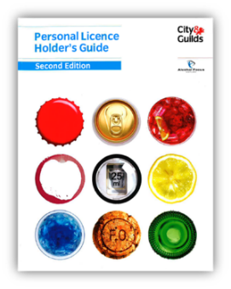 | This book would be of interest to those wishing detailed information about the Licensing (Scotland) Act 2005 in an easy-to-read format.  The Guide is supplied to all candidates attending the City & Guilds Scottish Certificate for Personal Licence Holders (SCPLH) and SCPLH Refresher courses. | £9.99

Please email your completed form to: training@alcohol-focus-scotland.org.uk

Terms & Conditions
Delivery of Your Materials
In line with current government advice Alcohol Focus Scotland staff are working remotely until further notice. We regret, therefore, that we are currently unable to guarantee timescales for providing materials. When we receive your order we will confirm timescales with you.
Payment for Your Materials
We will send you an order confirmation detailing your order and the overall cost.
Materials must be paid for before they will be dispatched.
Payment can be made by Bank Transfer to the following account:
- Royal Bank of Scotland
- Account Number: 10370011
- Sort Code: 830706
Your order confirmation will show an Order ID number which should be used for your payment reference along with your name.
e.g. Order ID 1 – Joe Bloggs
Please email us to confirm you have processed your payment and we will issue you with a receipt.
If you are unable to make a payment in this way, please let us know when submitting your order. Due to current Covid guidance we are restricted in the types of payments we can process but will try to support you on a best endeavour basis.
Data Protection
In compliance with the General Data Protection Regulation (GDPR), the information you have supplied will be stored securely in electronic form and will be used by Alcohol Focus Scotland to process your order and all related purposes. We will keep the information no longer than is necessary to do this.
Mailing List
We would also like to add you to our mailing list, to contact you occasionally with other information we think may be of interest to you, for example, new training materials or upcoming training opportunities.
If you consent to receive these mailings, you may opt out at a later date, by contacting us at training@alcohol-focus-scotland.org.uk
Please tick the box if you would like to receive this information. 

